Letter to Vincent during virus # 11 US Mail, not permitted hand delivery 3/27/20
Dear Vin
Today I had to come to the Carriage House early for Kurt was taking down a tree on Szurma corner property on 3rd Ave but getting at it from my property. It is quite exciting to watch as 1st outer branches come down and then they get to the big branches and trunk. At that point, they have to put a rope around the branch or trunk to guide it safely down.
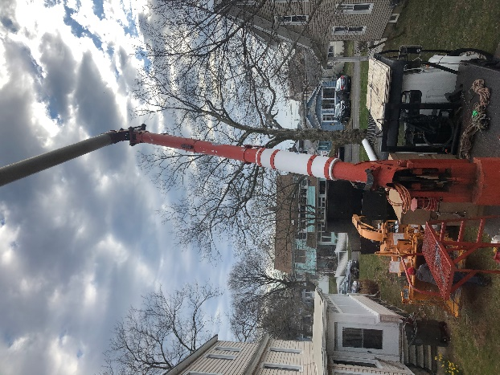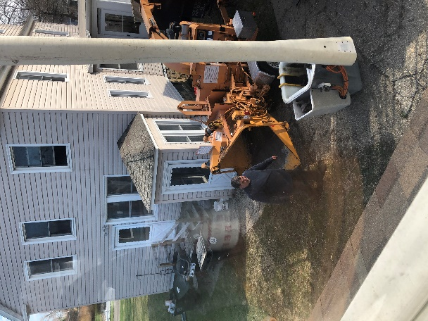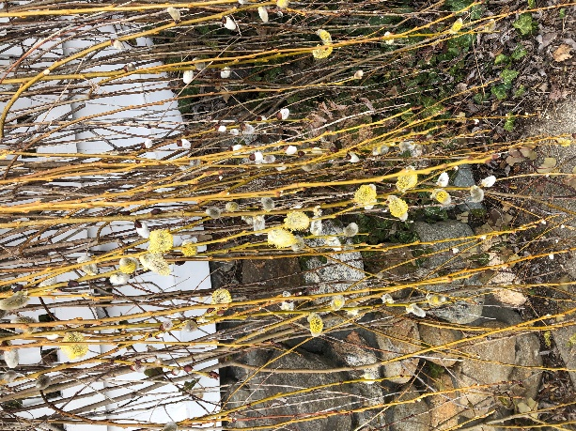
You can see not only the pictures from the beginning of the excitement but also a picture I took at Anchor beach the other day of Pussy Willows. I did not realize they had yellow seeds around their 1st appearance that they then shed and turned all white and furry.
I talked a good while with Len Szurma & his wife while the tree cutting went on. They were to take a Viking trip on the Danube from Budapest to Prague in a few months. But now they and other friends who had trips planned, ie: Lisa & Peggy & Helen & Carole-Lena and their husbands, all are wondering if their trip will be on, if they should cancel their trips, if trip insurance will pay or not since it does not cover pandemics. People can be out sizeable amounts of money, perhaps $10000 or more with life being so shut down due to the virus. I shared my booklet of our Budapest trip with the Szurmas. It is difficult to realize that was only 6 years ago. There is such a beautiful picture of us on the back of the booklet. You look the same these days but unfortunately can no longer count on your body to move as you wish. I have loved life with you, especially our trips, going to concerts, BACIO, Bridgeport Historical, and TV watching. These days are lonely by myself in your house. So you are stuck and wishing you were home, but I know that can’t be and I regret that.

Love Beth

