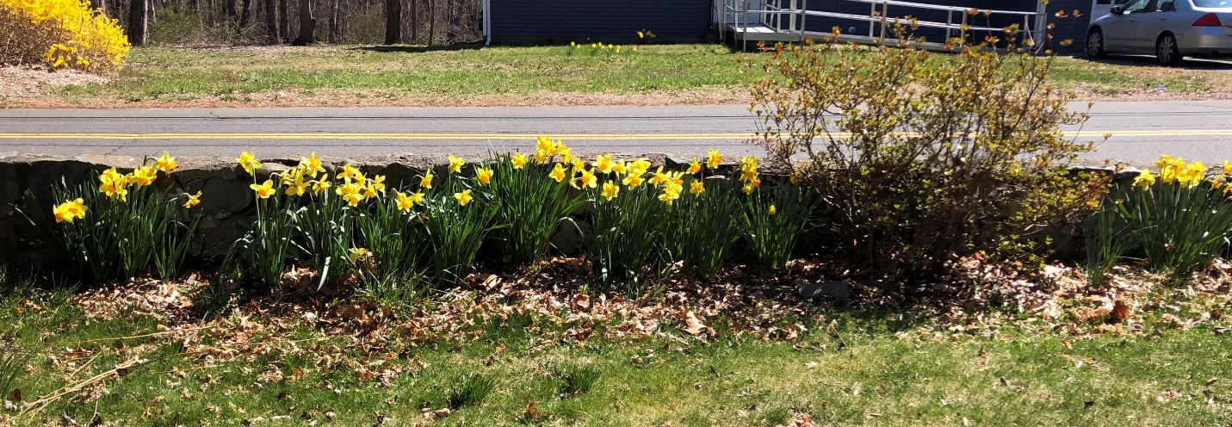
Letter to Vin during Covid19 virus # 18 April 3 2020
Dear Vin
This is how our yard looks today along the stone wall. The daffodils are out in more profusion than other years. I believe it is due to not taking the leaves away from the flower beds during winter. The daffodils stayed more protected I think.
Up close the stone wall does not look good, it has deteriorated during the past 5 years and so far, I cannot find a decent stone person to repair it at a low price. The man I had out would only give e the cost of an almost totally new wall. I’ll have to ask more people.
Today I straightened out the various Amica insurance policies and called them to get all on auto pay. You used to do this so well./ I find it a burden to deal with since they list them by their account numbers and not the names like Subaru or Kia or Brewster Rd.
I also updated your Garmin which had not been done for ages. It still works very well.
It was really nice getting a quick chance to see you on the Facebook phone call made by someone there at West River. Another time,. Instead of this taking us both by surprise, we should ask if they can do it at an appointed time that we should both know. Then you could figure out a bit ahead of time what you want to tell me. Since I write you every day, I will not have much to say and you can’t hear me anyway, so it would be your chance to talk!
Bye for now, going for a beach walk then will mail this on the way home. Beth

